Single Factor Designs

Class Examples – data posted in StatCrunch Group

1. The following is a partial analysis of variance table for 5 treatments and a total of 30 observations of the response variable. Complete the table and test the null hypothesis of no treatment differences, on average.

|  |  |  |  |  |  |
| --- | --- | --- | --- | --- | --- |
| Source | df | SS | MS | F-value | p-value |
| Treatments | 4 | 40 | 10 | 10/2.4=4.1667 | 0.0101175 |
| Error | 25 | 60 | 60/25=2.4 |  |  |
| Total | 29 | 100 |  |  |  |

Cutoff value from table F(4,25) = 2.76 at 5%

2. A filling operation consists of four identical machines that are set to pour a specified amount of a product into equal-sized containers. Random samples are taken periodically from the machines to check the equality of the average amounts poured by the machines. The following sample data were recorded for a particular time period.

Machine1 Machine2 Machine3 Machine4

15 18 18 19

14 19 18 20

15 18 19 18

16 18 17 19

14 19 19 18

16 19 18 19

Where G2=178929 and ∑∑x2 =7523

| **Column** | **n** | **Variance** | **Sum** |
| --- | --- | --- | --- |
| Machine1 | 6 | 0.8 | 90 |
| Machine2 | 6 | 0.3 | 111 |
| Machine3 | 6 | 0.56666667 | 109 |
| Machine4 | 6 | 0.56666667 | 113 |

**Use the information above to complete the ANOVA table below**

**ANOVA table**

| **Source** | **DF** | **SS** | **MS** | **F-Stat** | **P-value** |
| --- | --- | --- | --- | --- | --- |
| Columns | 3 | 56.458333 | 18.819444 | 33.706468 | <0.0001 |
| Error | 20 | 11.166667 | 0.55833333 |  |  |
| Total | 23 | 67.625 |  |  |  |

3. Independent random samples from four different brands of recently produced alkaline batteries were placed on a life test. The following lifetimes (in minutes) were observed:

|  |  |  |  |
| --- | --- | --- | --- |
| **Brand A** | **Brand B** | **Brand C** | **Brand D** |
| 110 | 118 | 108 | 117 |
| 113 | 116 | 107 | 112 |
| 108 | 112 | 112 | 115 |
| 115 | 117 | 108 | 119 |

Where G = 1807 and ∑∑x2 =204311

(a) State the null and alternative hypotheses for this study.

(b) Use the output and graphs below to check the assumptions have been met.

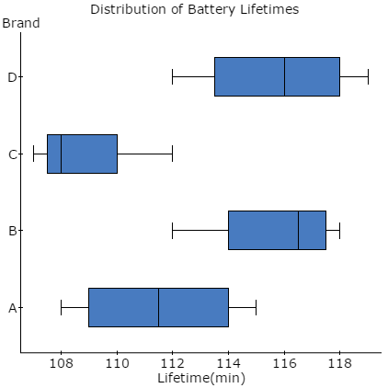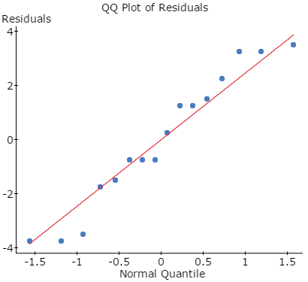

**Levene's Test for Homogeneity of Variance**

| **Test Statistic** | **DF 1** | **DF 2** | **P-value** |
| --- | --- | --- | --- |
| 0.33918129 | 3 | 12 | 0.7974 |

**(c) Complete the ANOVA table below**

**ANOVA table**

| **Source** | **DF** | **SS** | **MS** | **F-Stat** | **P-value** |
| --- | --- | --- | --- | --- | --- |
| Brand |  |  |  |  | 0.0086 |
| Error |  |  |  |  |  |
| Total |  |  |  |  |  |

(d) Interpret your results

**SOLUTIONS**

Independent random samples from four different brands of recently produced alkaline batteries were placed on a life test. The following lifetimes (in minutes) were observed:

|  |  |  |  |
| --- | --- | --- | --- |
| **Brand A** | **Brand B** | **Brand C** | **Brand D** |
| 110 | 118 | 108 | 117 |
| 113 | 116 | 107 | 112 |
| 108 | 112 | 112 | 115 |
| 115 | 117 | 108 | 119 |

Where G = 1807 and ∑∑x2 =204311



**STATE the null and alternative hypotheses**

Ho: The mean lifetimes (in minutes) of the four brands of alkaline batteries is the same.

Ha: At least two of the mean battery lifetimes are not the same.

**Check that the assumptions have been satisfied to conduct this test**.

Assumption 1: The samples of experimental units selected for the treatments must be random and independent.

*The batteries were randomly selected from each of the four brands.*

Assumption 2: The probability distributions of the populations of responses associated with each treatment must be all normal.



*All four normal probability plots do not show any evidence of non-normality*

Assumption 3: The probability distributions of the population of responses associated with each treatment must have equal variances.

Variable Mean StDev

Brand A 111.50 3.11

Brand B 115.75 2.63

Brand C 108.75 2.22

Brand D 115.75 2.99

*Dividing the largest standard deviation of 3.11 by the smallest standard deviation of 2.22 results in a value smaller than 2 so there is no evidence that the assumption of equal variance is violated.*

**Conduct the analysis**

Analysis of Variance

Source DF Adj SS Adj MS F-Value P-Value

Factor 3 141.69 47.229 6.21 0.009**

Error 12 91.25 7.604

Total 15 232.94

There is evidence to suggest that at least two of the mean alkaline battery lifetimes differ as the p-value of 0.009 is less than a significance level of 0.05.

Conduct post-hoc test to determine the difference between the mean battery lifetime.

a) Using output





Using Fisher’s LSD method

Df = 12 t* = 2.179 at 95% confidence

LSD = 2.179

Therefore batteries that have means that differ by more than 4.2488 minutes are statistically significant.

Variable Mean

Brand A 111.50

Brand B 115.75

Brand C 108.75

Brand D 115.75

Brand A and Brand B are not different (barely? maybe)

Brand A and Brand C are not different

Brand A and Brand D are not different (barely? maybe)

Brand B is statistically significantly different from Brand C but not from Brand D

Brand C is statistically significantly different from Brand D

So that Brands A, B and D are not statistically significantly different from each other but they are all different from Brand C

Recommendation: But the cheaper battery from either Brands A, B or D but the safe but would be the cheaper of either Brand B or D.